Professional Computing - CITS3200 Team 30

**Team Meeting #1**

horizontal line

**Date:** 07.08 **/ Time:** 3.30pm **/ Location:** Teams (Online)

**Chair:** Jordan Lee

**Minutes:** Jordan Lee

**Attendees:** Jordan Lee, Zack Zou, Edward Giles, Alexia Fassetta, Nicodemus Ong

**Apologies:**

## **Meeting Duration:**

# 

# The meeting was declared open at 3.30 pm, quorum was present.

# The meeting was declared closed at 4.30 pm, quorum was present.

## **Confirmation of Previous Minutes:**

**Motion:** To accept the 04.08.2022 minutes as true and correct

**Moved:** Jordan, Zack, Edward, Alexia, Nic

**Moved Unanimously /** Moved by Majority

**AGENDA**

| **Topic:** | **Actioned**: |
| --- | --- |
| Review items in Sprint 1 | All |
| Discuss what languages & technologies to be used in project | All |
| Assign tasks to group members | All |
| Weekly Submission | Alexia F |

**MINUTES**

## Sprint 1

Scope of Work

* Target audience: Tanya Ward, admin team, associates of NCARD
* Instruction
* Milestones
* Purpose
* Proposed System
* Functional & Non Functional Requirements
* User Interface and Human Factors
* Documentation
* Hardware Consideration - need a server to run it on
* Security Issues
* Database Model

Skills and resources Audit

* We will get back to this later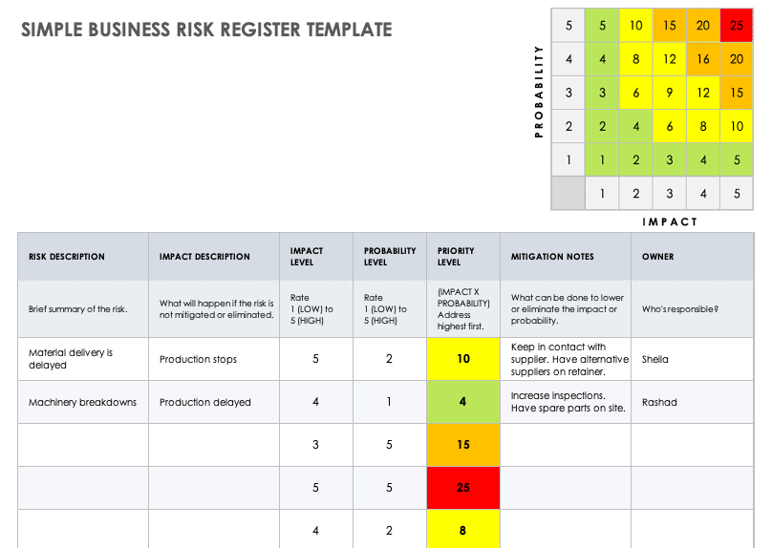

Risk Register

* Description, rating of severity, how to mitigate/ avoid
* Possible Risks
  + Time management
  + Communication barriers
  + Technical issues
  + Leaking sensitive data
  + Change of scope

Project Acceptance

* Engagement with specified audience
* Discuss with to Tanya about
  + Acceptance criteria
* Follow the example test manual (<https://bit.ly/3Qln89I>)
  + Minimum 5 Tests
* Automatic testing

Set of user stories

* “short requirements or requests written from perspective of an end user”
* Define some stories based on project description and information gathered
* Discuss with Tanya
* Bundle w acceptance criteria (Ed)

## 

## Skills and Resources Audit (languages & technologies in project)

Team members

* Nic -> Java, Python, MySQL
* Jordan -> Python, R, front-end web dep
* Zack -> Java, Python, MySQL, SQL, unit automated testing
* Alexia -> Python, SQL, R
* Edward -> C#, Java, Python, PHP, PostgreSQL

Evaluated Flask Vs Django

* Both Flask and Django have built-in HTML templates and automated testing
* Django has better efficiency, more straightforward
* Django has built-in protection against several common attack mediums, such as CSRF, XSS, and SQL injection.
* Flask does not support asynchronous request handlers.
* Django 3.1, supports asynchronous handlers.

Backend: Python - Django

Database: MySQL

Front-end Web: html, javascript, vue.js

## Assign tasks to group members

Alexia

* Tanya Meeting Thursday or Friday 6pm
* Sprint items 1-2

Edward:

* Sprint items 3-5

Jordan

* Sprint items 1-2

Nic

* Sprint items 3-5

Zack

* Sprint items 1-2